**Ideation Phase**

**Define the Problem Statements**

|  |  |
| --- | --- |
| Date | 19 September 2022 |
| Team ID | PNT2022TMID04139 |
| Project Name | Project - AI - Based localisation and classification of skin disease with Erythema |
| Maximum Marks | 2 Marks |

PROBLEM STATEMENT:

Mrs.Gangadevi is a 32 year old women. She is suffering from Psoriasis for past 1 year.During this period of time she faced severe rashes,dryness in skin,flakiness,peeling and redness. Initially she did’nt mind about the disease but later due to her peer environment she faced lot of problems like stress,low-confidence level,low self-esteem and less social participation. She is unaware of what disease she is affected with and wants to know about it in detail to cure it. So,Gangadevi needs an immediate remedy for the diseases he wants to know which specialist to get consulted with.

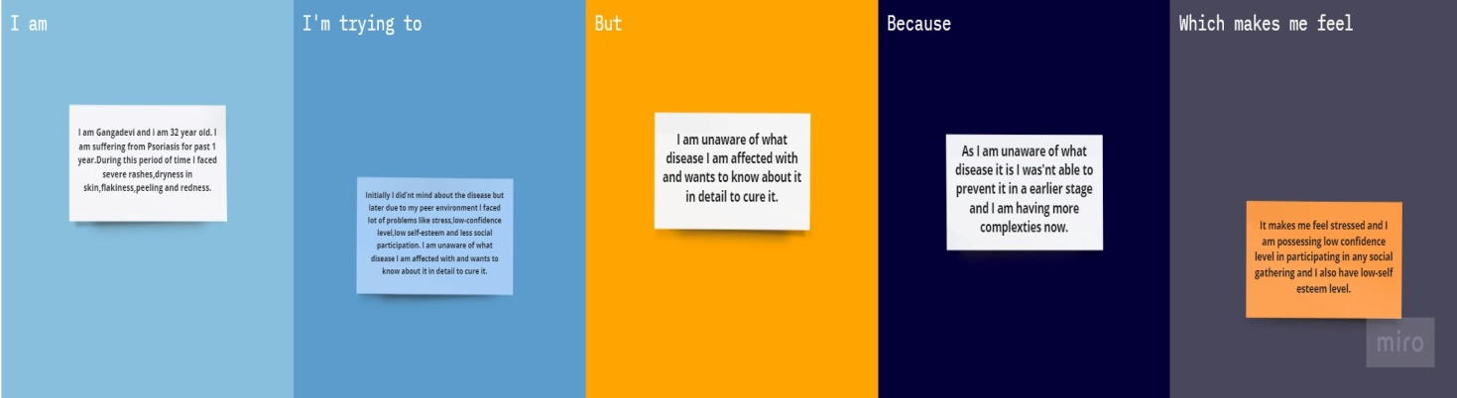

|  |  |  |  |  |  |
| --- | --- | --- | --- | --- | --- |
| **Problem Statement (PS)** | **I am (Customer)** | **I’m trying to** | **But** | **Because** | **Which makes me feel** |
| PS-1 | **I am Gangadevi and i am 32 year old. I am suffering from Psoriasis for past 1 year.During this period of time I faced severe rashes,dryness in skin,flakiness,peeling and redness.** | **Initially I did’nt mind about the disease but later due to my peer environment I faced lot of problems like stress,low-confidence level,low self-esteem and less social participation. I am unaware of what disease I am affected with and wants to know about it in detail to cure it.** | **I am unaware of what disease I am affected with and wants to know about it in detail to cure it.** | **As I am unaware of what disease it is I was'nt able to prevent it in a earlier stage and I am having more complexties now.** | **It makes me feel stressed and I am possessing low confidence level in participating in any social gathering and I also have low-self esteem level.** |